Bite Size Update
RCP Customer Improvements…. We have been busy!
Background
You will be aware that some Edinburgh Leisure venues have introduced access gates into their reception areas, enabling customers to self-serve instead of stand in queues.

This project was planned to commence in May however when lockdown struck the project was delayed. I am delighted to say that we are now back on site working hard to deliver some of these customer improvement projects in readiness for opening on Monday 14th September and I hope you like the changes.

What are we doing at RCP?

- The reception desk has been reduced in size
- We have installed 3 kiosks into the reception area, these are initially for club customers to self-serve at.
- We have introduced access control entry gates at the following positions:
  - Entrance to gym
  - Entrance to the arena (spectator area) and access to all studios
  - To the left of reception – entrance to wet changing areas
- We have also created a new exit route which will enable a one-way system for customers exiting the wet changing areas. This has resulted in us opening the area beside the lift and creating an exit route there

What does the plan look like?

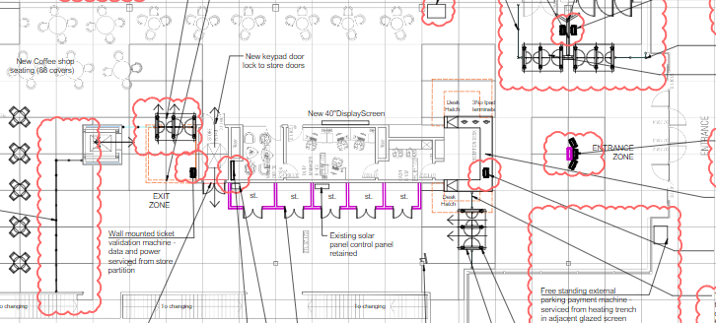

What happens next?
We are currently programming access fobs for all our staff and permanent service providers that you can access the areas you need to at the times required. This will be issued to you at a pre site visit if you have one or during the first week of opening.

What other changes have we made?
The car park has become busier and busier making it a challenge for customers to get parked. The situation has been made worse by members of the public / local workers making use of the car park when they are not using the facilities.

We have therefore decided to modernise the car park control system by introducing a new barrier system and implementing customer charges in both car parks, the aim is for this new system to go live around 17th September.

We will offer our customers 3 hours of free car parking and any time more than this, will be chargeable (like Fountainpark)

What will the car park customer journey be?
- Customer drives to barrier and takes a ticket from machine
- Attends activity as normal
- Before leaving – they scan their ticket using one of the 5 validators placed around the centre.
- Inserts validated ticket into the payment machine (even if within 3 hours this still needs done), payment machines are in the foyer area and outside the front door
- Drives to the barrier which will open automatically if ticket has been processed in pay machine (using number plate recognition)

If a customer forgets to pay / validate their ticket, then there will be a contactless payment reader at the exit barrier where they can pay

Validators will be located:
- On reception
- At the exit route from the wet changing rooms / beside the lift
- At the exit gates from the gym and arena walkway (2)
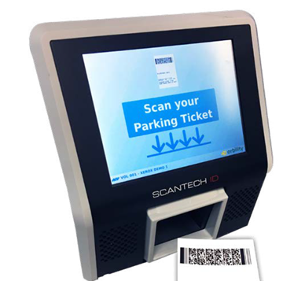
- On the Clambers reception desk - beside the sign out sheet

What are the customer charges (those who validate in venue)?
0 – 3 hours FREE for customers
3 – 4 hours £2.00
4 hours plus £10.00

There will be a 15-minute grace period to enable customer drop offs and pickups to take place. This pricing structure has been designed to enable most customers to access free parking and those who wish to stay around for longer will need to pay. We feel that a 3-hour visit is a reasonable allowance.

We want to discourage members of public from parking in the car park therefore if a non-validated ticket is presented to the pay machine the charge will be £10.00 for under 3 hours or £20.00 for longer than 3 hours. We have located the validators within easy access areas to avoid members of the public who have not used the facilities being able to validate their ticket and claim the free parking.
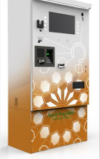

Both payment machines will take card payments only as we are moving to cashless within the facility – (all areas)

How will this effect staff, service providers & personal trainers?

- Staff and those who are regular service providers to RCP, will have their car registration plate pre-programmed into the software meaning the barrier will open and close for you as you approach it (no need for any tickets)

What do I need to do?

Please let us know if you are a member of staff who is not based at RCP but regularly accesses the facility and will need an access fob or your car programmed into the number plate recognition system, please contact Jackiemills@edinburghleisure.co.uk and these will be organised next week.

Please be aware that if you access the car park using number plate recognition, you must inform us if you change your car - otherwise you will not get access.

Like anything, this is a period of change for RCP but I hope you will like the improvements we have made.
If you have any questions, please get in touch.

Further Information:
If you have any queries or questions, please contact:
Claire Rusack: RCP Manager
Clairerusack@edinburghleisre.co.uk

